**Week 2 (ELECTRONICS):**

Three tasks for this week:

1-Design a Brushless motor

2-Write algorithm and draw electronic circuit for servo motor

3-Write algorithm and draw electronic circuit for stepper motor

1-)

The brushless motor has mainly two parts that cause rotation, Rotor and Stator. Electronic current will be passed through the stator (which is a coil wrapped around metal) this current will generate a magnetic field that will move the rotor, usually two stators will work at the same time one attracting part of the rotor and the other repulsing it.

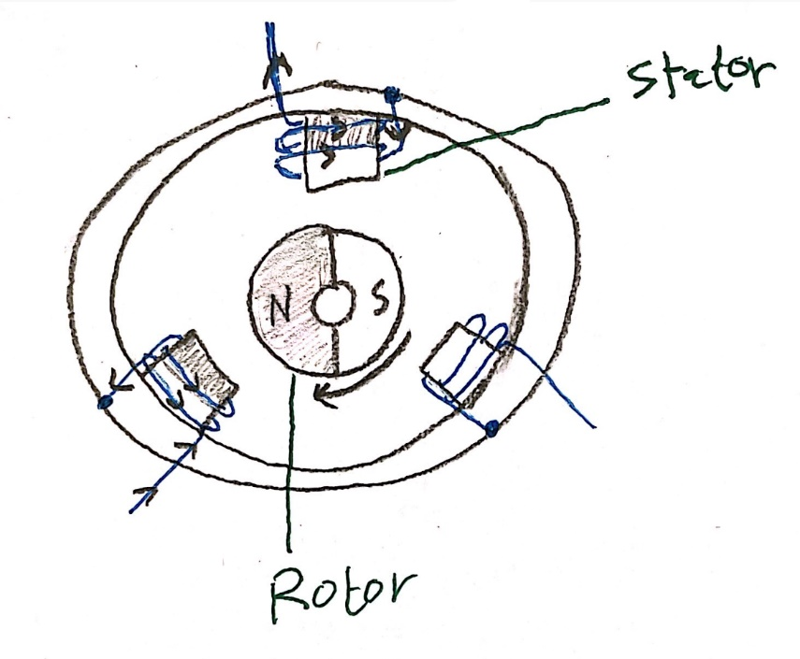

2-) Servo motor code and circuit:

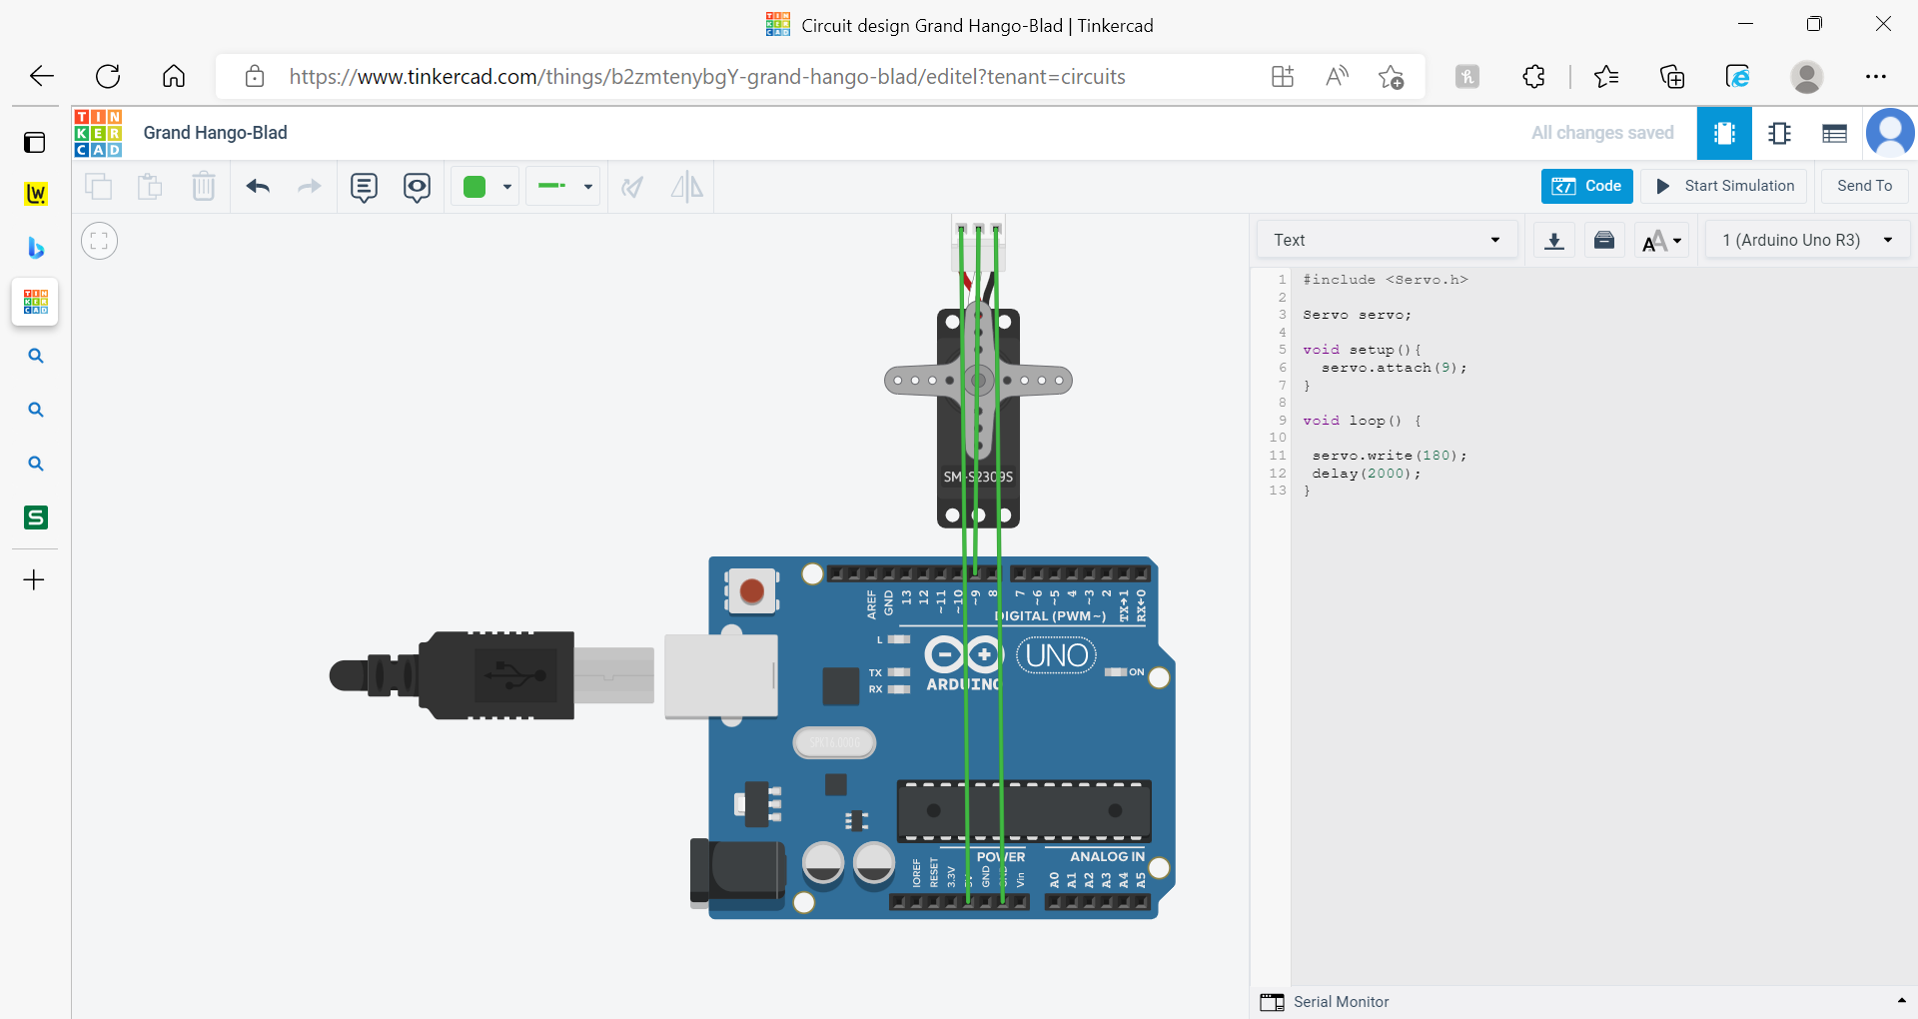

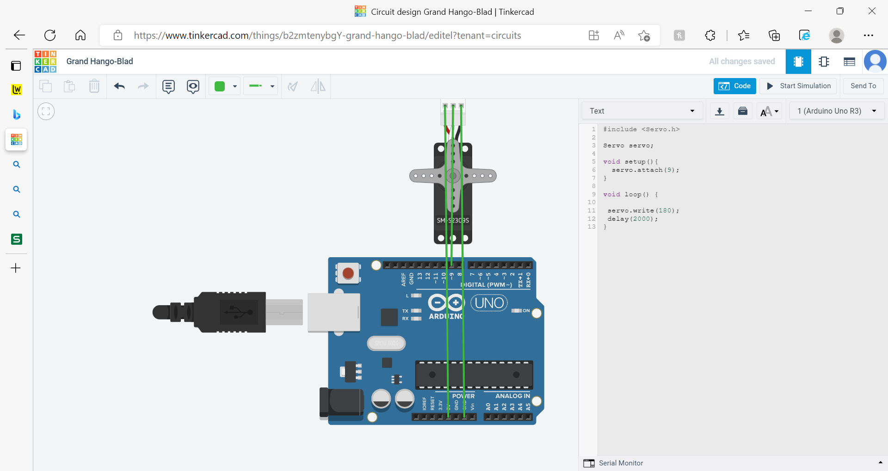

3-) Stepper motor code and circuit:

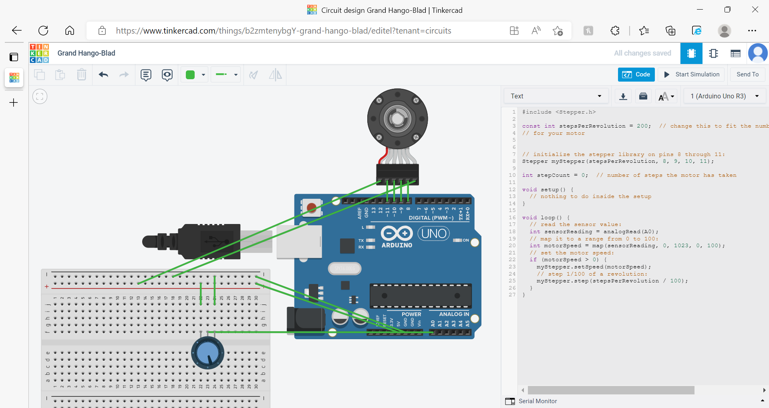

(this code was copied from [User Hanwen CH | Tinkercad](https://www.tinkercad.com/users/9Xb08uZvLrc-hanwen-ch))

